**ME 318M Homework #1**

Name: Jingsi Zhou

UT EID: jz24729

Section Number: 17460

**Problem 1:** Given: Var1 = 1.234, Var2 = 7.789, Var3 = 1.457

>> Var1 = 1.234;, Var2 = 7.789;, Var3 = 1.457;

1. 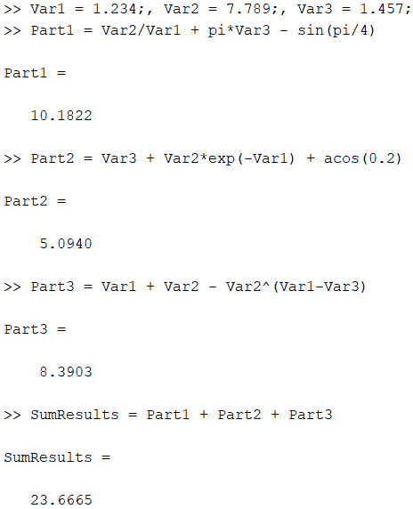Ans: 10.1822
2. Ans: 5.0940
3. Ans: 8.3903
4. Ans: 23.6665

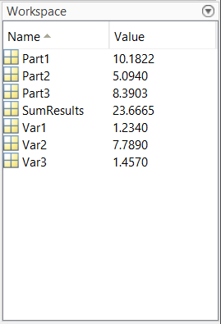

**Problem 2:** Given L1 = true, L2 = false, L3 = false, L4 = true

1. 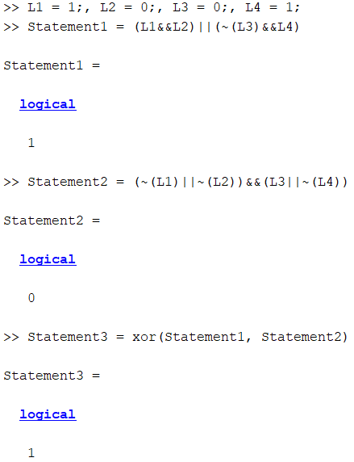Ans: true
2. Ans: false
3. 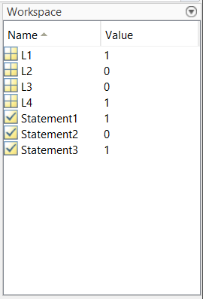Ans: true

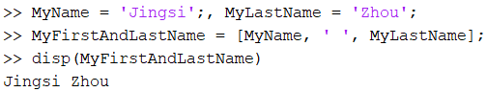**Problem 3:**

